Team Jett Use Cases

**Start Menu (By Justin Ostopick)**

**Basic Course:**

The user opens the game and is brought to the main menu screen where they have the options to click the buttons of Single Player, Multiplayer, Options or Exit. The userclicks single player or multiplayer and is brought to the save screen.

**Alternate courses:**

**Options Button:** The user clicks on the options button and is brought to the options screen.

**Exit Button:** The user clicks on the exit button and quits out of the game.

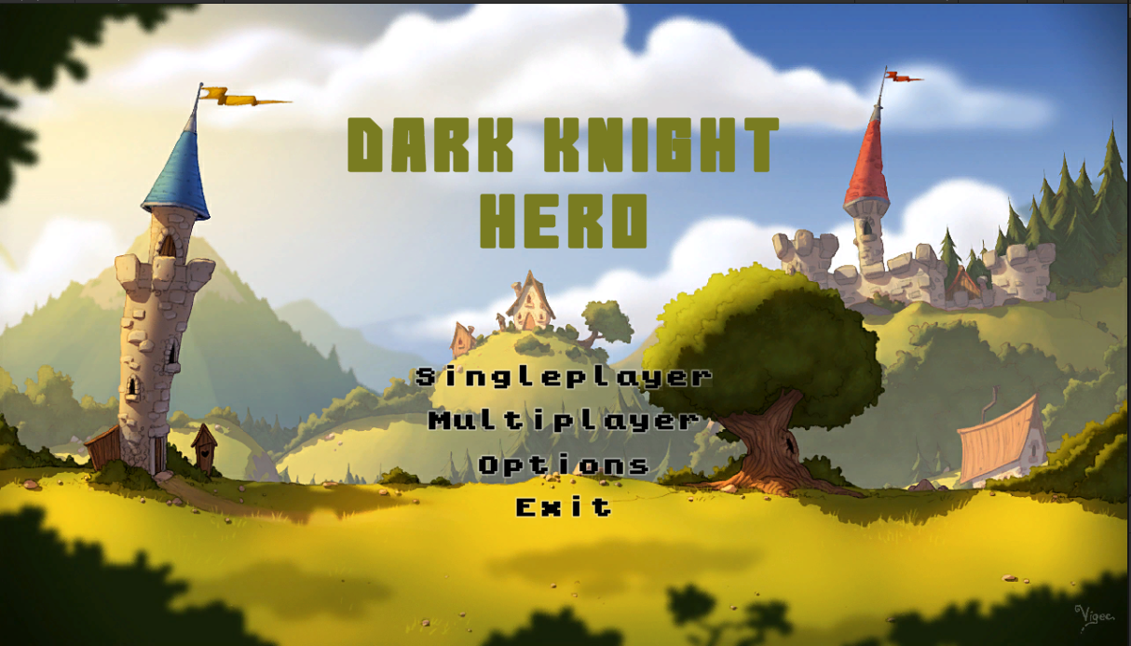

**Save Screen Use (by Micah Wenger)**

**Basic course:**

The user selects one of the three game save slots and clicks on it (*if the save slot is empty*). The user clicks “new game”, then the user loads into the start scene game environment.

**Alternate courses:**

**Load save:** (*if the save slot is not empty*) The user clicks load, then the user loads into the game environment, resuming from the beginning of the scene where the game was last saved from.

**Delete:** The user clicks the delete button, and “yes” when asked for confirmation. Then the save file for the selected game state is deleted and the save slot is now empty allowing the user to create a new save in its place or copy a new save to that slot.

**Copy save:** The user clicks the copy button and then the user clicks an empty save slot to copy to. The save state from the original slot is duplicated to another slot.

**Back Button:** The user clicks the back button and is returned to the main menu screen.

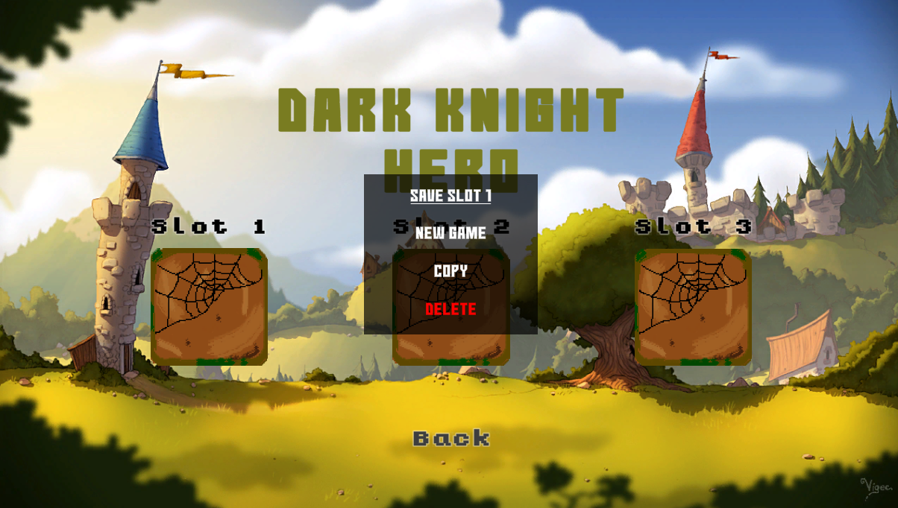

**Start Game (by Cris Herrera)**

**Basic Course:**

The system displays the Main Menu screen and the user clicks the Start button. The user clicks the Start New Game button then system starts the Tutorial Scene, allowing the user control the Player. The Start Scene creates a Game Manager, Camera Motor, Level, Enemies, Chests, and NPC.

**Alternative course:**

**The user loads into a save:** The system displays the Main Menu Screen and the user clicks the Start button. The user clicks on the Load Game button and the system starts Previous Scene, allowing the user to control the player. The Previous Scene loads a Game Manager, Camera Motor, Level, Enemies, Chests, and NPC.

**Pause Menu (by Collin Barletta)**

**Basic course:**

The user presses the esc key while in game in order to bring up the escape menu. From here the user has the option buttons of options, save game, exit game, return to game. The user can press the esc key or the return to game button to leave this menu.

**Alternate courses:**

**Options:** While in the menu the user clicks the options button and are brought to an options screen where the user can adjust some of the settings in the game.

**Save Game:** While in the menu the user clicks the save game button and the system saves the game.

**Exit Game:** While in the menu the user clicks the exit button then are brought back to the main menu screen.